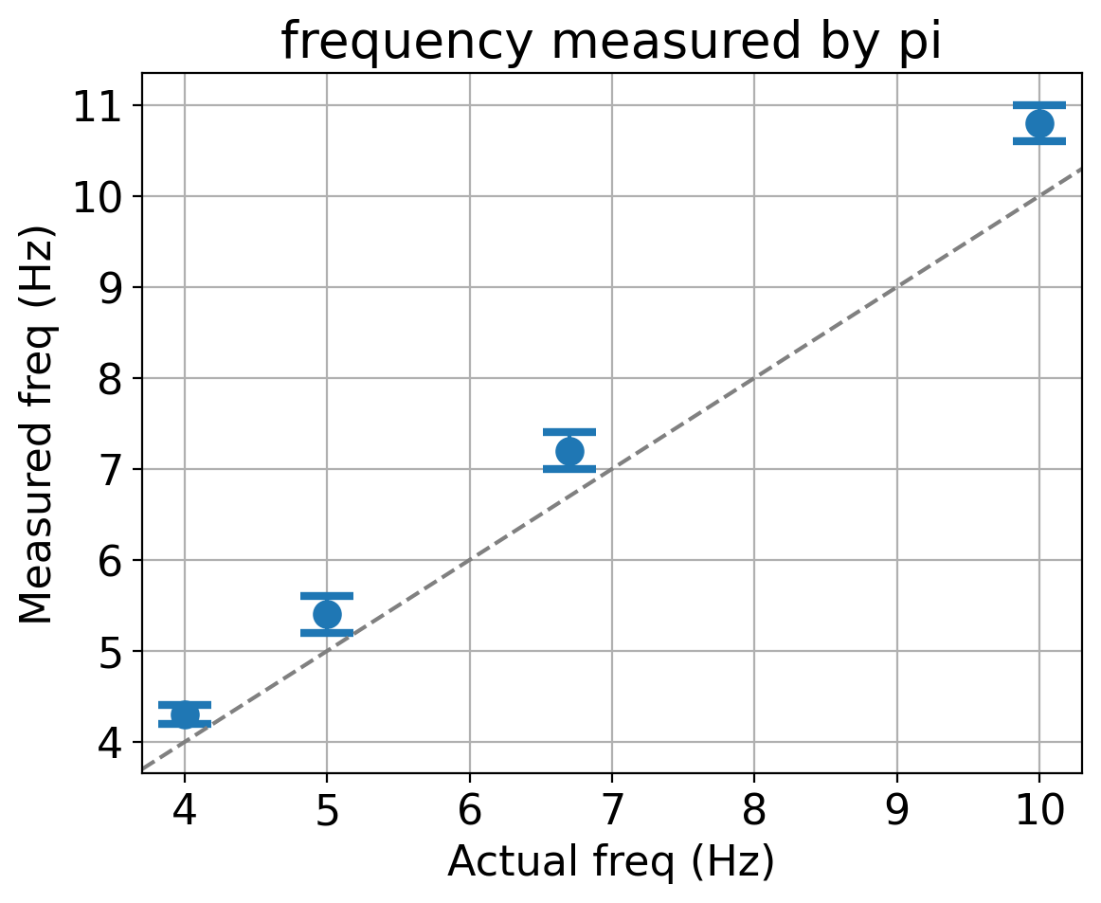
x=[4,5,6.7,10,] # actual freq (Hz)
y=[4.3,5.4,7.2,10.8,] # measured freq
yerr=[0.1,0.2,0.2,0.2] # measured err

- We imitated the bubble signal by assuming it to be a square pulse which is 10-15 ms wide.
  - Actual bubble should be around 20 ms wide, consisting of 2 pulses.
- Frequency is estimated by counting the number of signals in 5 sec, taking 100 samples every second
- We looked at 4 different frequencies between 4-10 Hz
  - Actual bubbling rate might be less or within this range, more than this should be alarming
- Signal was sent to the first and last channel of the multiplexer, separately and all the four ADCs, two at a time
  - The maximum possible error range that was seen is reported
- Frequency measured is higher than actual frequency because in the script, we assume that it takes a fixed amount of time to run the script. The actual time taken is slightly longer than what we assume.
- There is an easy fix to this by instead of assuming how long it takes, find out how long it takes in the script.
- Pictures of how a 10 Hz and 5 Hz signal looks is below

